**Library.App User’s Guide**

Library.App – Application which implements simplified version of a Library application.

Application was developed using basic ASP.NET MVC 4 Application template.

Use-Case Diagram, which follows application, contains a management scheme and functional of all roles – librarians (admin) and users.

1. **Roles**

Application maintains two roles: Librarian as administrator of library, user as customer.

**Librarian’s options:**

* Registration or logging in;
* Search books;
* Record all book’s issues, returns and usage history;
* Add and remove books;
* Send messages to users;
* Cancel user’s membership.

**User’s option:**

* Search books.

Records to database connected with creating or deleting account, giving books away and their returning support by messages to user’s e-mail.

1. **Entrance to the application**

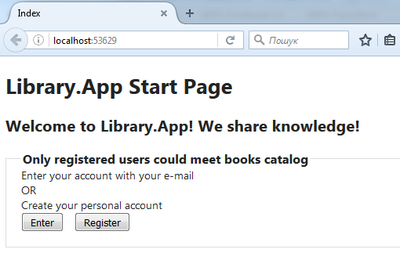

The main entrance form describes two options – to enter application with your personal registered e-mail or to make registration of new account.

Registration procedure requires only name, last name, e-mail (and password for librarians, which is by default – “Password”).

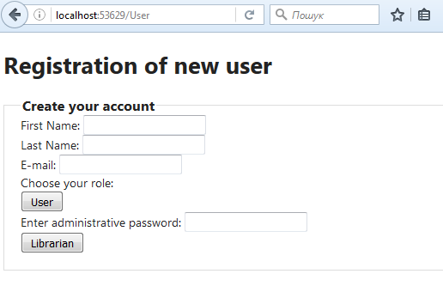

If customer makes registration as User role he could fill only three first gaps and press User. That’s enough for User’s account. But registration of Librarians requires correct password.

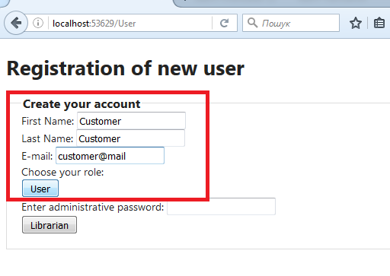

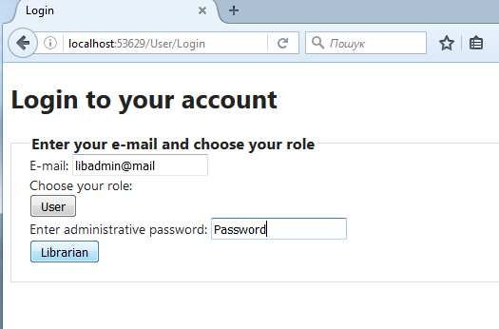

1. **Search books option**

Search books option is available for both roles – librarians and users. But, some block of this information for user is useless. Application doesn’t return any other information about other users – just UserID.

Picture describes main search book menu.

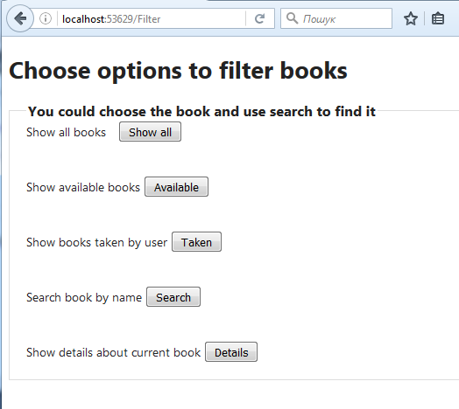

The list of all books, which are registered in library.App, is available in option “Show all”.

Following table contains order number, Book ID, book’s title and list   
of authors or single author. Books are sorted by title.

Table consists of 10 rows. User could observe other just pushing buttons “Previous” or “Next”.

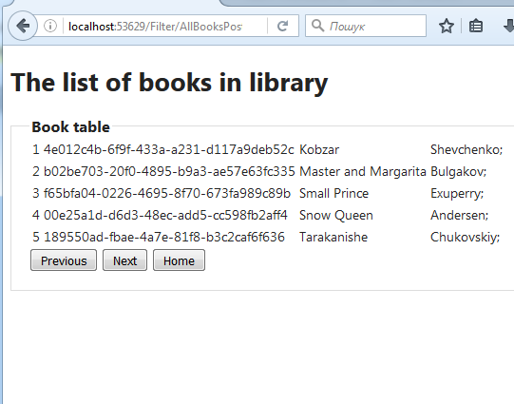

The list of available books, which are registered in library.App, is enabled in option “Available”.

Following table contains order number, Book ID, book’s title and list   
of authors or single author. Books are sorted by title.

Table consists of 10 rows. User could observe other just pushing buttons “Previous” or “Next”.

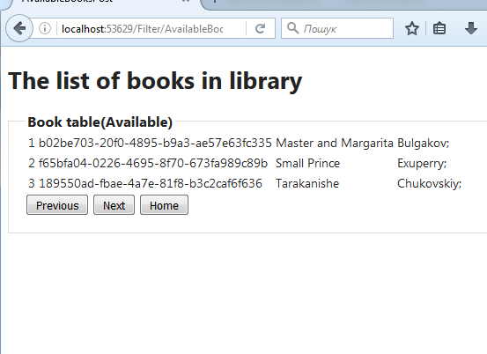

The list of books which were taken by current User is enabled in option “Taken”.

Following table contains first and last name of User, amount of his books, order number, Book ID, book’s title.

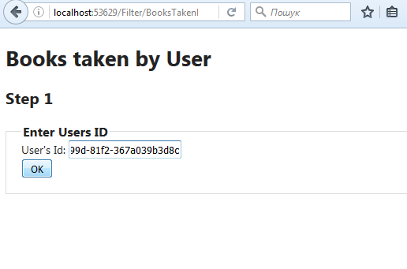

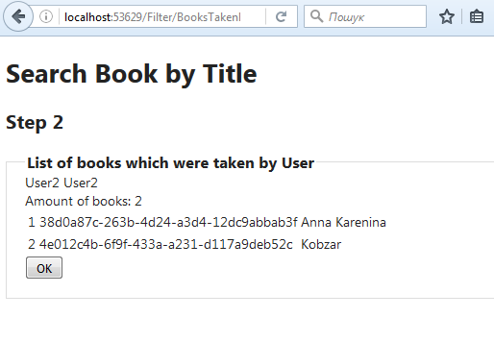

To search book by its title just push button “Search”, fill gap with its title. Than, you could see details about current book such as usage history, current keeper, etc. This information is available in option “Details”.

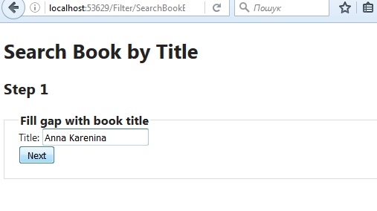

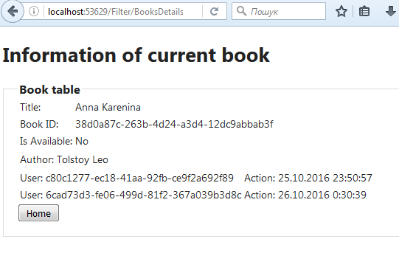

1. **Main Librarian Menu**

For logging in as Librarian Role you have to enter your mail and password (“Password”). Than push button “Librarian”.

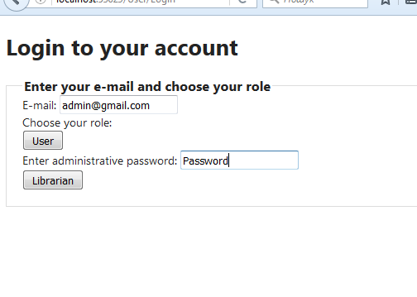

The main Librarian Menu consists of wider options than User Menu:

* Registration or logging in;
* Search books;
* Record all book’s issues, returns and usage history;
* Add and remove books;
* Send messages to users;
* Cancel user’s membership.

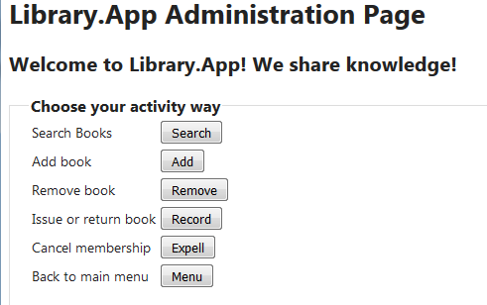

1. **Add Book**

Librarian could add new book to the library. Just enter books title…

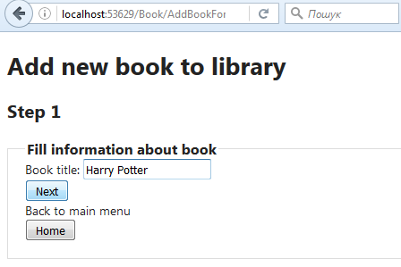

…fill information about author. If book has list of authors librarian could push button “More” and set other authors.

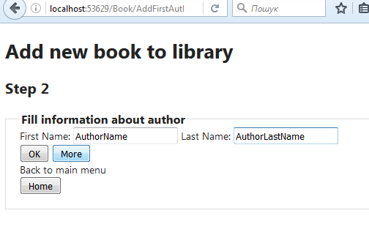

Such message is the sign that book was successfully added to library database.

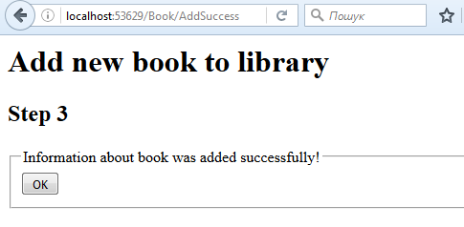

1. **Delete books**

Librarian could delete book from the library. Just enter books title…

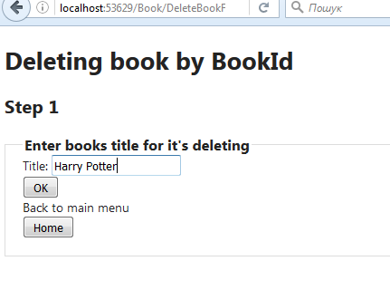

…fill information about Book ID. Choose it from the list of books with the same titles. NOTICE, that on the left side from the book title lays Book ID. On the other side – User ID , who is its keeper for that moment. Nullable ID means that book has no keeper. It is available for readers.

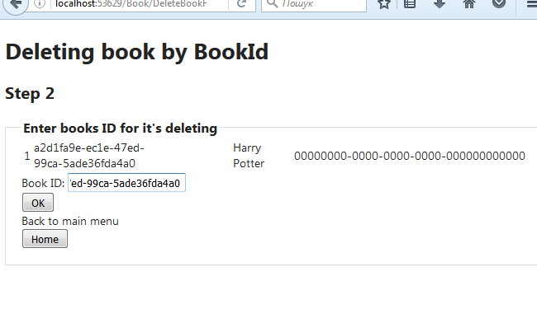

Such message is the sign that book was successfully deleted from library database.

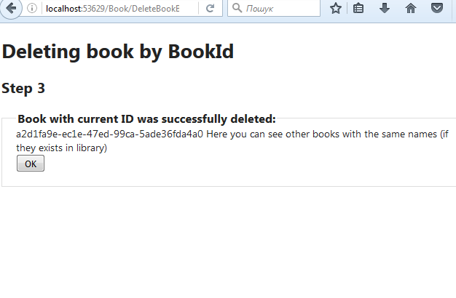

1. **Giving books away**

Librarian could give book away from the library. Just push “Give” button…

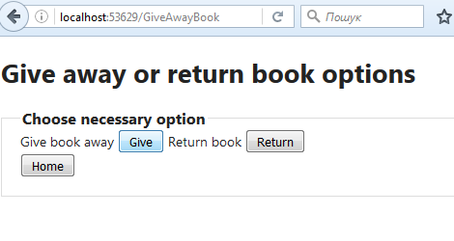 **…** enter books title…

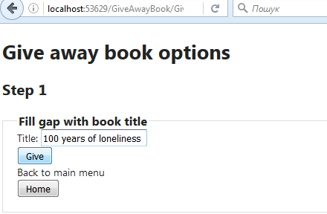

…fill information about Book ID. Choose it from the list of books with the same titles. And fill gap with current user email. NOTICE, that on the left side from the book title lays Book ID. On the other side – User ID , who is its keeper for that moment. Nullable ID means that book has no keeper. It is available for readers.

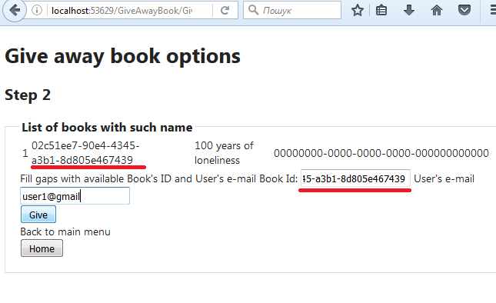

Such message is the sign that book was successfully given away from library to current user – customer, and system send special message to users e-mail (asynchronously).

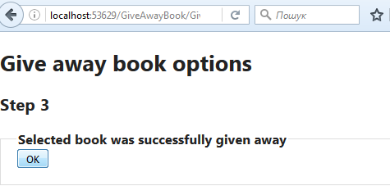

1. **Return book**

Librarian could return book from customer to the library. Just push “Return” button, enter books title…

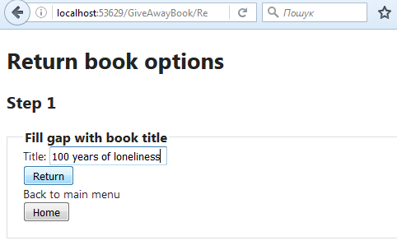

…fill information about Book ID. Choose it from the list of books with the same titles. And fill gap with current user email.

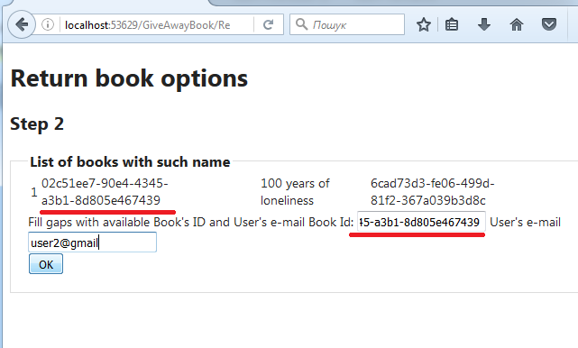

Such message is the sign that book was successfully returned to library and system send special message to users e-mail (asynchronously).

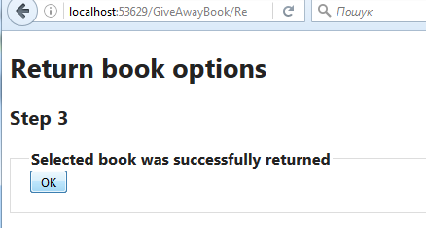

1. **Delete user**

Librarian could delete current user from the library. Just push “Expel” button, enter user’s e-mail.

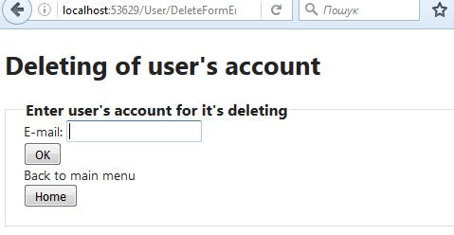

**Kiselov Oleksandr**

[dp.prk.kiselov@gmail.com](mailto:dp.prk.kiselov@gmail.com)